A Summer Industry Internship – I Report

on

**Accident Location on Indian Roads**

Submitted in partial fulfillment of the requirement

For

The award of degree of

**BACHELOR OF TECHNOLOGY**

in

**CSE- ARTIFICIAL INTELLIGENCE AND MACHINE LEARNING**

|  |  |
| --- | --- |
| Submitted By |  |
| M.Pavan | 21311A6629 |
| Himanshu Parida | 21311A6623 |
| K.Reveanth | 21311A6628 |

Under the Guidance of

Dr T V RAJINI KANTH

Head of Department CSE-AIML



**DEPARTMENT OF**

**CSE- ARTIFICIAL INTELLIGENCE AND MACHINE LEARNING**

**SREENIDHI INSTITUTE OF SCIENCE AND TECHNOLOGY**

**(AUTONOMOUS)**

**Yamnampet (V), Ghatkesar (M), Hyderabad – 501301, A.P.**

**AY-2023-2024**

**DEPARTMENT OF**

**CSE- ARTIFICIAL INTELLIGENCE AND MACHINE LEARNING**

**SREENIDHI INSTITUTE OF SCIENCE AND TECHNOLOGY**



**CERTIFICATE**

This is to certify that this Project-II report on “**Accident Location on Indian Roads**”, submitted by **M.Pavan (21311A6629) , Himanshu Parida (21311A6623) , K.Revanth(21311A628)** in the year 2023 in the partial fulfillment of the academic requirements of Integrated Electronics(INTEL) for the award of the degree of Bachelor of Technology in CSE- **ARTIFICIAL INTELLIGENCE AND MACHINE LEARNING**, is a bonafide work that has been carried out by them as a part of their **Project during Second Year Second Semester,** under our guidance. This report has not beensubmitted to any other Institute or university for the award of any degree.

|  |  |  |
| --- | --- | --- |
| **Internal guide** | **Project Coordinator** | **Head of the Department** |
| **Name** |  | **Dr. T V Rajinikanth** |
| **Designation** | **Assistant Professor** | **Professor & HOD** |

**Department of CSE- Artificial Intelligence and Machine Learning**

**Signature of the External Examiner**

Date: -

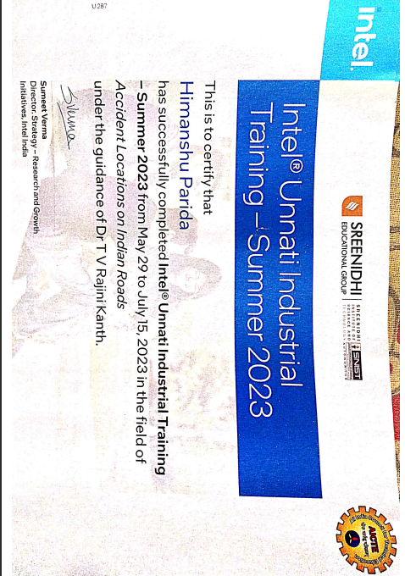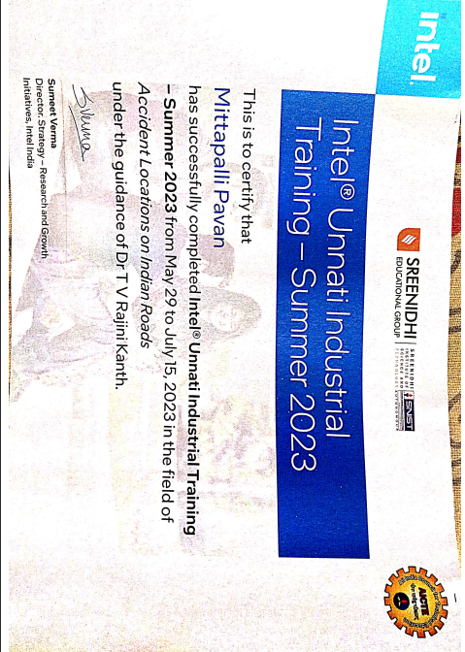**Completion Certificates**

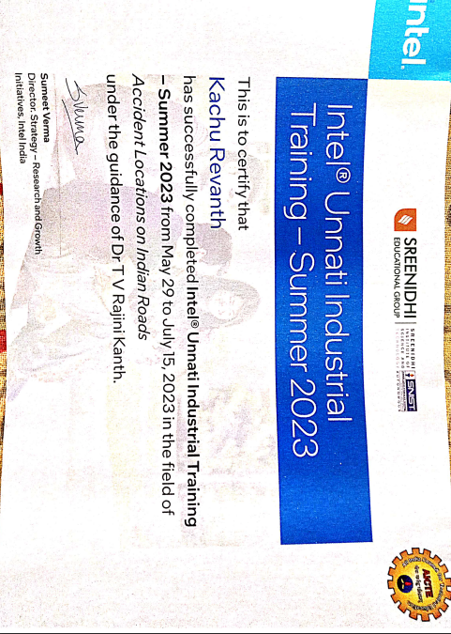

**DECLARATION**

We, **M.Pavan (21311A6629), Himanshu Parida (21311A6623), K.Revanth (21311A6628)** students of **SREENIDHI INSTITUTE OF SCIENCE AND TECHNOLOGY, YAMNAMPET, GHATKESAR,** studying III year I semester, **CSE- AI&ML** solemnly declare that the Project-I work, titled “**Accident Location on Indian Roads ”** is submitted to **SREENIDHI INSTITUTE OF SCIENCE AND TECHNOLOGY** for partial fulfillment for the award of degree of Bachelor of technology in **CSE- ARTIFICIAL INTELLIGENCE AND MACHINE LEARNING**.

It is declared to the best of our knowledge that the work reported does not form part of any dissertation submitted to any other University or Institute for award of any degree.

**ACKNOWLEDGEMENT**

I would like to express my gratitude to all the people behind the screen who helped me to transform an idea into a real application.

I would like to express my heart-felt gratitude to my parents without whom I would not have been privileged to achieve and fulfill my dreams. I am grateful to our principal, **DR. T. Ch. Siva Reddy,** who most ably runs the institution and has had the major hand in enabling me to do myproject.

I profoundly thank **Dr. T V Rajinikanth**, Head of the Department of **CSE- Artificial Intelligence and Machine Learning** who has been an excellent guide and also a great source of inspiration to my work.

I would like to thank our Coordinator **Mr. G Ravi** & my internal guide **Name of the Guide** for Project-II for their technical guidance, constant guidelines, encouragement andsupport in carrying out my project on time at college.

The satisfaction and euphoria that accompany the successful completion of the task would be great but incomplete without the mention of the people who made it possible with their constant guidance and encouragement crowns all the efforts with success. In this context, I would like to thank all the other staff members, both teaching and non-teaching, who have extended their timely help and eased my task.

|  |  |
| --- | --- |
| **M.Pavan** | **21311A6629** |
| **Himanshu Parida** | **21311A6623** |
| **K.Revanth** | **21311A6628** |

**ABSTRACT**

The project report focuses on analyzing accident locations on Indian roads and developing strategies to mitigate road accidents. Road accidents in India are a major concern, leading to numerous fatalities and injuries annually.

Understanding the specific locations where accidents occur and identifying contributing factors is crucial for implementing effective road safety measures. This report presents a comprehensive analysis of accident data, including urban areas, highways, junctions, poorly maintained roads, and pedestrian zones. Factors such as speeding, reckless driving, drunk driving, distracted driving, and inadequate infrastructure are identified as significant contributors to accidents.

To address these challenges, the report proposes strategies such as infrastructure improvement, speed management, driver education and training, public awareness campaigns, and data-driven interventions. By implementing these strategies, it is expected that road safety can be enhanced, leading to a reduction in accidents and a safer transportation system in India.

INDEX

|  |  |
| --- | --- |
|  | **Page No** |
| **List of Figures** |  |
| 1. **INTRODUCTION** |  |
| **2. IMPLIMENTATION AND RESUTS** |  |
| 2.1 Language / Technology Used |  |
| 2.2 Sample Code |  |
| 2.3 Results / Output Screens |  |
| **3. DATA SOURCES** |  |
| **4. CONCLUSION** |  |
| 1. **REFERENCES** |  |

**1. INTRODUCTION**

Road accidents are a persistent and significant problem in India, resulting in a high number of fatalities, injuries, and economic losses each year. The Indian road network, being one of the largest in the world, spans diverse landscapes and accommodates a vast volume of vehicles, including cars, motorcycles, buses, and trucks. However, the rapid growth in vehicle ownership and inadequate infrastructure development have contributed to increased road accidents.

The aim of this project report is to analyze and present findings on accident locations on Indian roads basically known as Blackspots. This knowledge will serve as a foundation for proposing strategies and interventions that can be implemented to enhance road safety across the country.

The report will utilize comprehensive accident data collected from reliable sources, including government records, police reports, and accident databases. Advanced analytical techniques will be applied to identify accident hotspots, trends, and patterns. The evaluation of various factors, such as road design, traffic volume, infrastructure quality, and geographical features, will help in pinpointing areas of concern.

**2. IMPLEMENTATION AND RESULTS**

**2.1 PYTHON LIBRARIES USED IN THE PROGRAMS**

**Streamlit:** The Streamlit module in Python is a powerful tool for quickly creating interactive web-based data visualizations and applications, allowing developers to seamlessly share their data insights with others.

**Numpy:** NumPy is a library for the Python programming language, adding support for large, multi-dimensional arrays and matrices, along with a large collection of high-level mathematical functions to operate on these arrays.

**Plotly:** The Plotly module in Python offers a versatile and interactive data visualization library, enabling developers to create visually stunning and customizable plots, charts, and graphs for effective data exploration and storytelling.

**Seaborn:** The Seaborn module in Python provides a high-level interface for creating visually appealing and informative statistical graphics, allowing users to effortlessly generate beautiful visualizations with minimal code and maximum impact.

**Matplotlib:** The Matplotlib module in Python is a widely-used plotting library that allows developers to create a wide range of static, animated, and interactive visualizations, making it a versatile tool for data exploration and presentation.

**Pandas:** It is a Python library used for working with data sets. It has functions for analyzing, cleaning, exploring, and manipulating data. The name "Pandas" has a reference to both "Panel Data", and "Python Data Analysis".

**2.2 SAMPLE CODE**

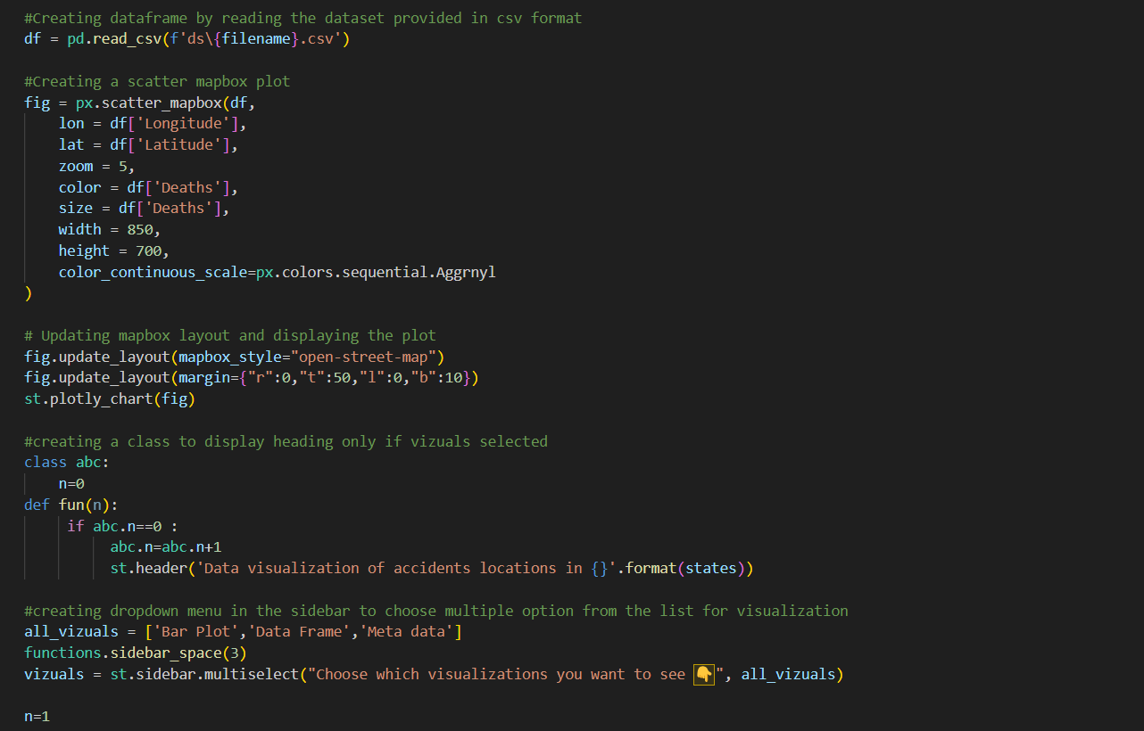

*Fig 1.1 Code for Accident Location on Indian Roads*

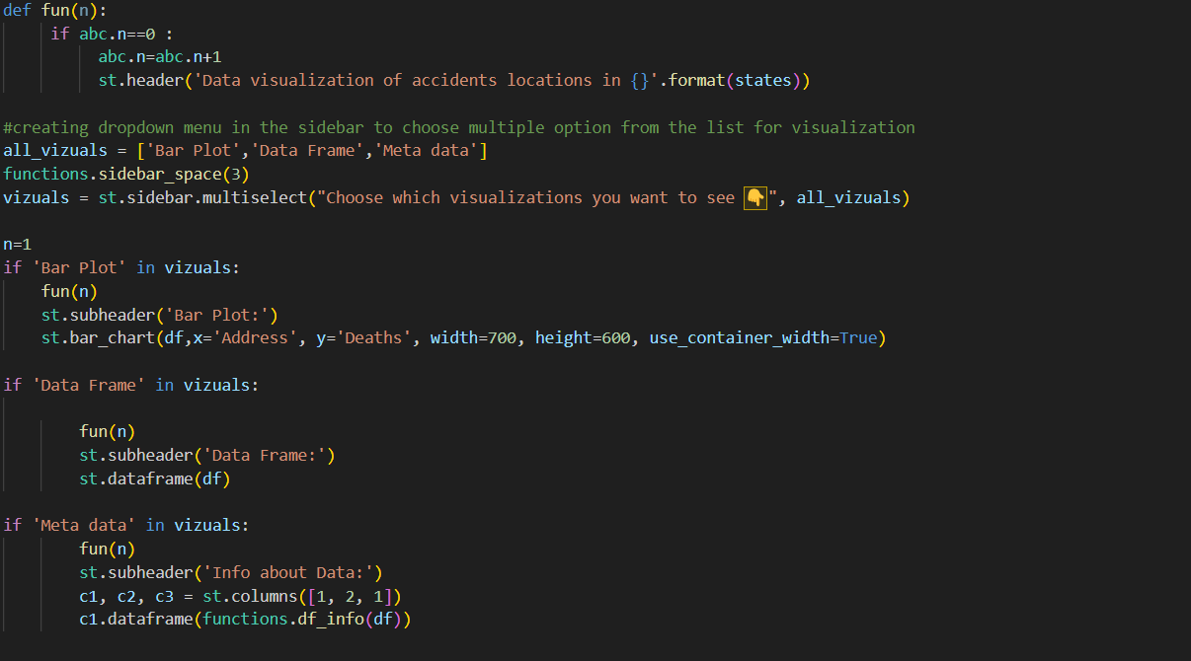

*Fig 1.2 Code for Accident Location on Indian Roads*

**2.3 RESULTS**

* It displays the various location on the India map with the total number of accidents at each location .
* It also provides the data in the form of Bar plot , Data frame and Meta Data for the Data Visualization

**Fig 2: Map of accident locations in India**

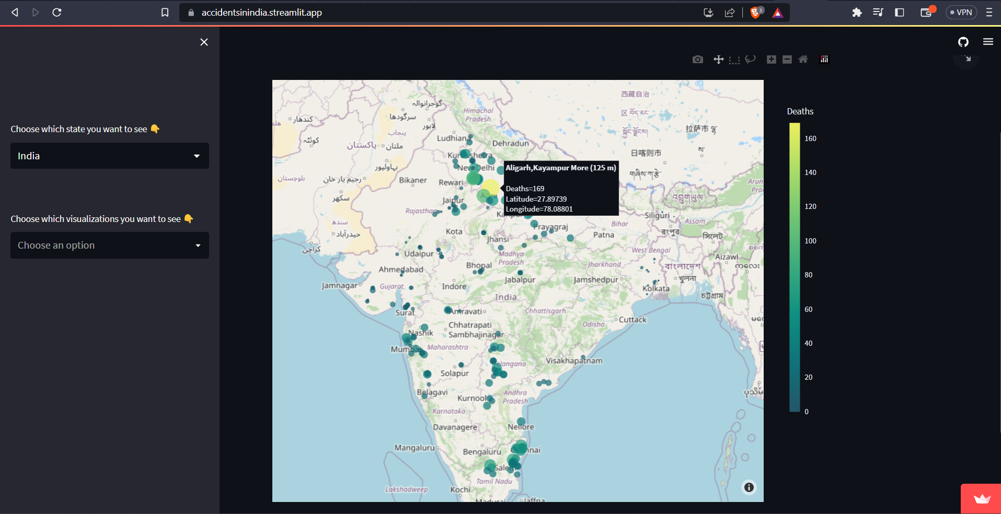

**Fig 3: Bar Plot for Data Visualization**

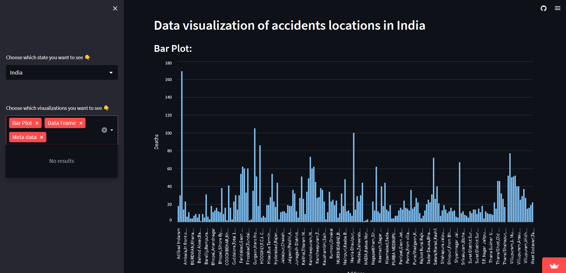

**Fig 4: Data Frame for Data Visualization**

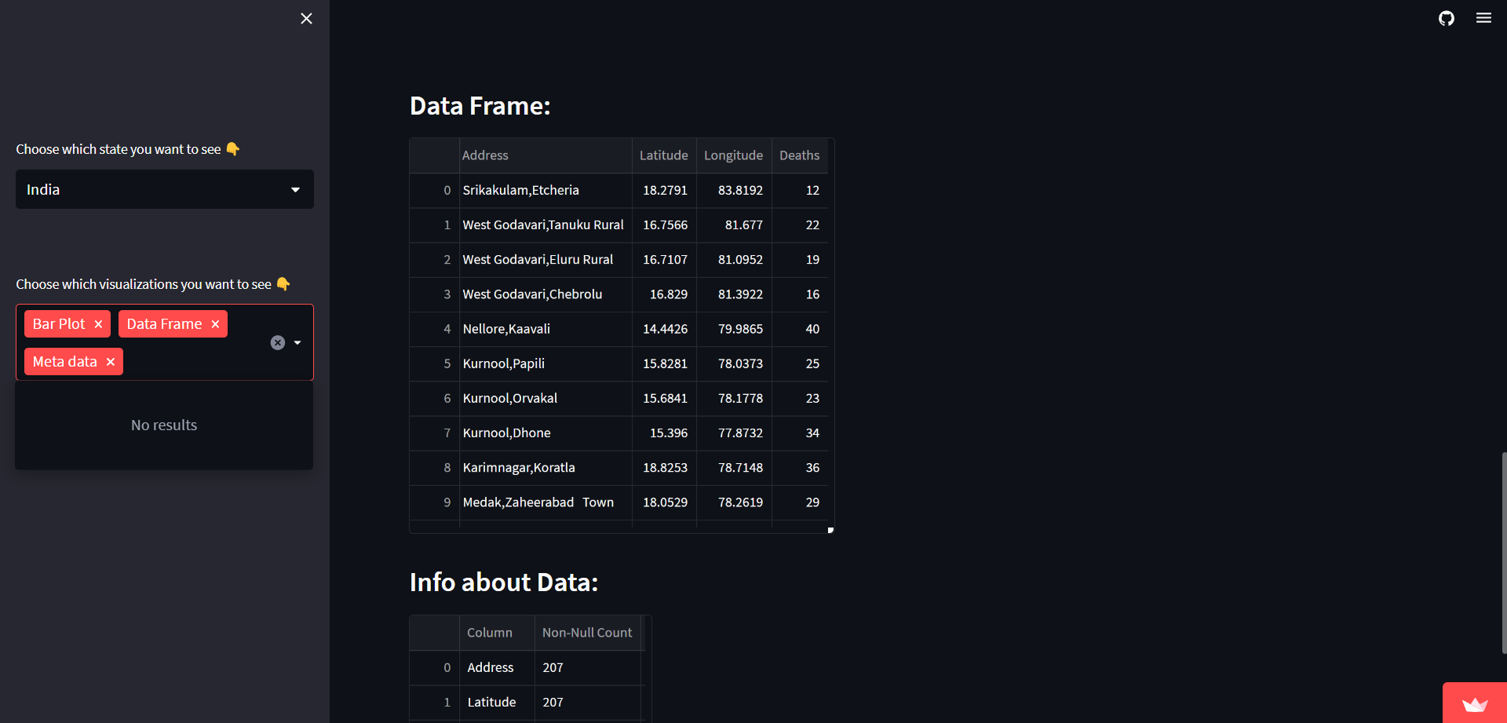

**Fig 5: Metadata for Data Visualization**

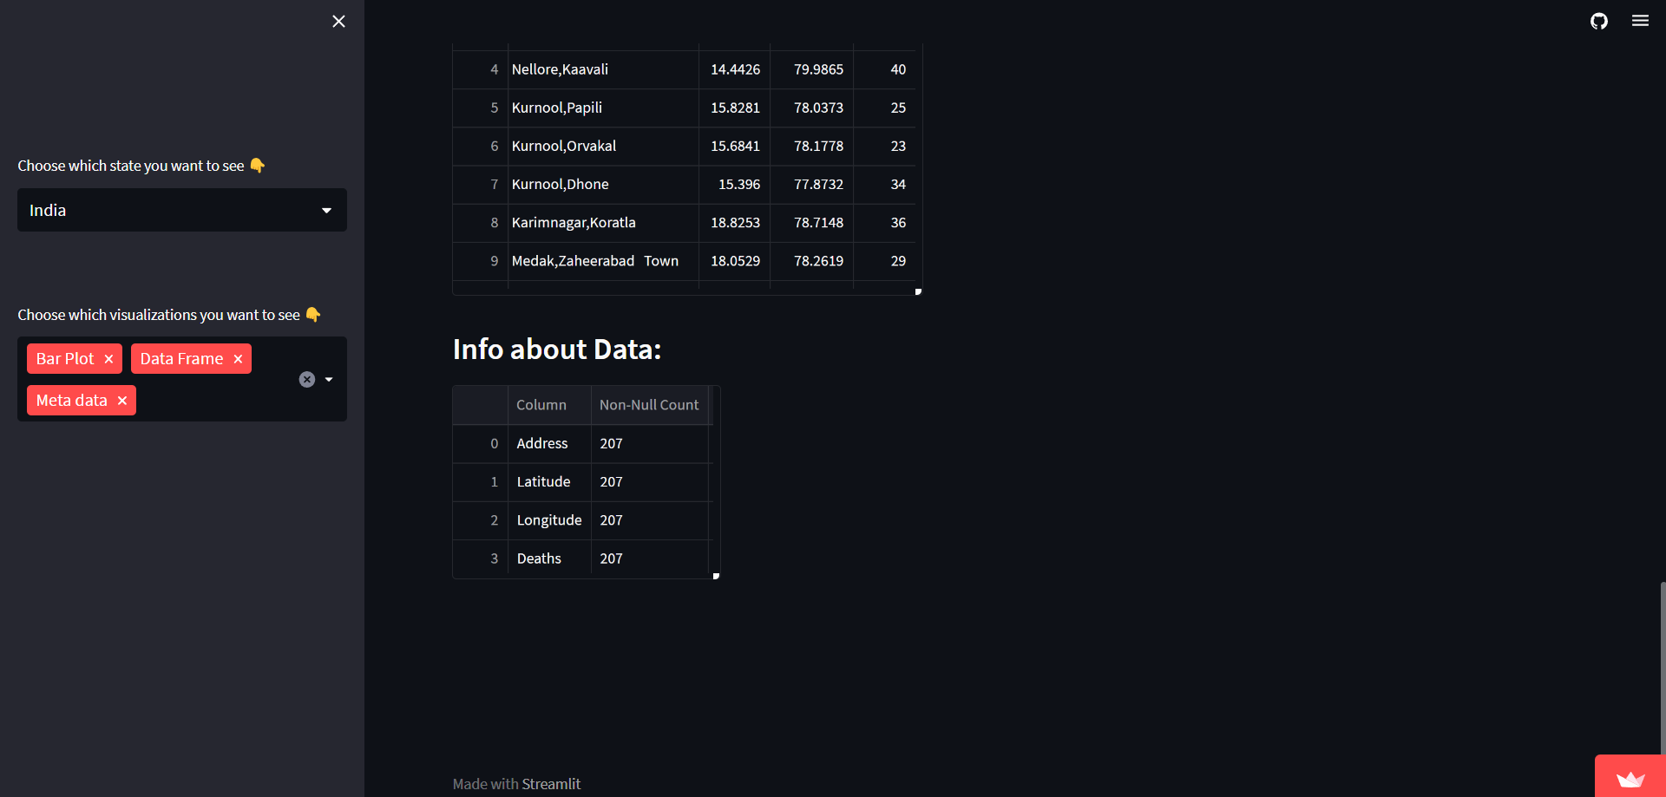

### 

### 3. DATA SOURCES

Downloaded and analyzed the accidents locations India at specific locations using [(morth.nic.in/black-spot)](https://morth.nic.in/black-spot) website these are the blackspots provided by the Indian government.

We have taken data with coordinates from given websites and all the are converted to csv format.

Developed code to take the input from the given datasets and it plots using the coordinates.

Developed a code for visualizing the data using Bar plots, Meta data etc…

### 4. CONCLUSION

In conclusion, this project has provided valuable insights into accident locations on Indian roads by analyzing spatial patterns and identifying contributing factors. The findings offer actionable information for policymakers and transportation authorities to prioritize interventions effectively, focusing on high-risk areas and addressing variables such as road infrastructure, traffic density, weather conditions, and driver behavior. By leveraging advanced analytical techniques, we can work towards reducing road traffic accidents, fostering safer travel, and creating a more resilient society in India.

**URL**

[**https://accidentsinindia.streamlit.app/**](https://accidentsinindia.streamlit.app/)

### 5.REFERENCES

[1].  [(data.gov.in/resources)](https://data.gov.in/resources)

[2]. [(visualize.data.gov.in/)](https://visualize.data.gov.in/)

[3]. [( community.data.gov.in/state-ut-wise-cases-of-road-accidents-during-2020/)](https://community.data.gov.in/state-ut-wise-cases-of-road-accidents-during-2020/)

[4]. ([NumPy](https://numpy.org/))

[5].[(www.indiatoday.in/india/story/deaths-india-road-accidents-data-infographic-1959819-2022-06-08)](http://www.indiatoday.in/india/story/deaths-india-road-accidents-data-infographic-1959819-2022-06-08))

[6].[(morth.nic.in/)](https://morth.nic.in/)

### 